Topic No. (select from the category listing)
Faculty or Student (Indicate your category identification)

Abstract Reference No: 0000
(Obtained through Website)

iCANX SUMMIT 2022 TEMPLATE AND INSTRUCTIONS FOR ABSTRACT PREPARATION
Zhigang Wu1, Peng Fei1 and Haixia Zhang2
¹Huazhong University of Science and Technology, Wuhan, China
²Peking University, Beijing, China
Presenting author: zgwu@hust.edu.cn
Introduction. The iCANX summit will be held 26 – 29 April 2022 in Wuhan, China, in conjunction with Huazhong University of Science and Technology 70th anniversary celebration. Authors are invited to contribute original presentations on advances in fundamentals, technologies and applications and for cutting edge of fundamental sciences, applied sciences, biological and medical sciences, and interdisciplinary sciences.
The iCANX summit Technical Program Committee encourages submission of original work that contains significantly novel material for on-site presentation. The abstract submission deadline is 15 March 2022.
Methods. Submitted abstracts should be two pages: one text page (500 words or less, 11-point font) and one page of figures and tables on either A4 Standard (21 cm x 29.7 cm) or US Standard (8.5 x 11 inches). If your abstract exceeds the 550-word limit, it will not be possible to upload and submit your abstract. The title, topic (selected from the category listing), authors, affiliations and all text must fit on the first page. The second page should contain all figures or tables. References may go on either page. All other style formatting is up to the authors. The language should be in English.
Results&discussion. The purpose of an Abstract submitted to iCANX summit 2022 is to inform the Technical Program Committee which new original results you propose to present. Therefore, it is important within the first few sentences to state what your primary result and novelty is. For example: "This paper reports a new method to artificially program the internal structure of porous media and hence mechanical response. With such a programmed structure, we can selectively tune mechanical response and hence its sensitivity on normal pressure or stress for dynamic human-machine interaction” It is also important to identify how the new work differs from previous work of your own group and other groups. For example: "The tunability of normal pressure sensitivity was reported at MEMS ‘20 [1], and an analysis of the new fabrication process on 3D fabrication, has been reported at Transducers 2021 [2]. Our method differs from that of group X [3] in the specific method of fabrication details we are using, and of group Y [4] in the geometry of xxx within the structure."
After an introduction of the basic ideas and how the work relates to other work, please, present detailed descriptions of hypothesis, methods, device structures, and examples of specific results, whether experimental or theoretical. Figures and Tables can support these results. For example: "A schematic view of structural programmed porous media is shown in Figure 1, with a close-up detail of the simulation in Figure 2. A cross-section of the fabricated sample is shown in Figure 3. Table I shows the comparisons of the performance of different approaches for selective sensitivity tunability [2]." After presentation of results, it is useful to benchmark specific results against related work and to comment on the broader impact of the results.
Please make sure that all the figures/photographs are clearly visible. The fact that the program committee cannot clearly see and understand the role of visual aids will be viewed negatively. All selected abstracts are eligible for the best paper prize and student presenters’ are eligible for the best student prize. There is no formal proceedings published.
Word Count: 535

Figure 1: Conceptional sketch of xxx showing

Figure 2: Simulated xxx of xxx in 300 dpi

Figure 3. Micrograph of xxxxxxxxx

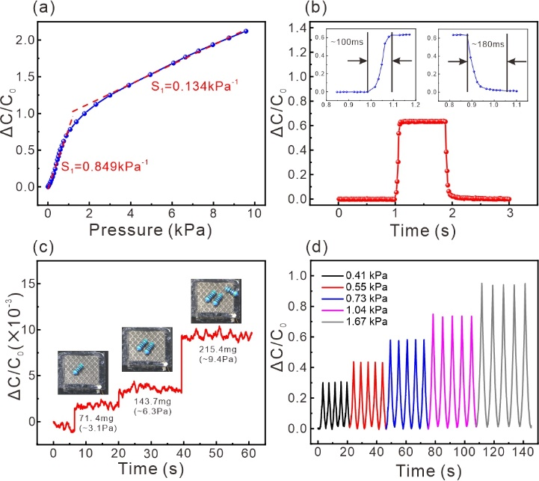
Figure 4: DATA, Results of xxxxxxxxxx

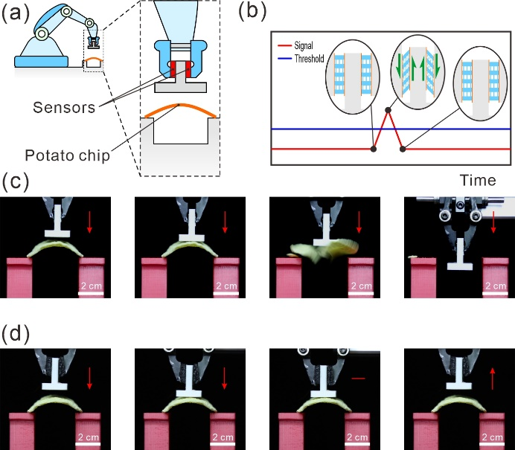
Figure 5. Demonstration for xxx
Table 1. Example of a table
Different  sensors | Performances
 | Sensitivity(kPa⁻¹) | Response time(ms) | Threshold(Pa)
This work | 0.849 | 100 | 3.1
REFERENCES
1. Z. Chai, et al "Uniformly distributed self-filling micro-strips for high-performance pressure-sensitive sensor" in Proc. 16th Annu. IEEE Int. Conf. Nano/Micro Engineered and Molecular System, Xiamen, 2021, pp. 1390-1393.
2. Z. Chai, et al, “Anisotropic Shear-Sensitive Tactile Sensors with Programmable Elastomers for Robotic Manipulations,” ACS Appl. Mater. Interfaces, vol. 13, no. 43, pp. 51426–51435, 2021.
3. W.-K. Chen, Linear Networks and Systems. Belmont, CA: Wadsworth, 1993, pp. 123–135.

