Systematic studies on the properties of poly(lactic acid) (PLA)/liquid polybutadiene rubber (LPB) reactive blends

Sung-Wook Lim^{1,2}, Myeon-Cheon Choi¹, Jae-Hoon Jeong², Eun-Young Park¹ and
Chang-Sik Ha^{*2}

¹Korea Institute of Footwear & Leather Technology, Busan 47154, Korea.
²Department of Polymer Science and Engineering, Pusan National University, Busan 46241, Korea

(Received , Revised , Accepted )

Abstract. Following our previous work, we have conducted further systematic studies to investigate the effects of reactive blending on the thermal and mechanical properties of blends of poly(lactic acid) (PLA) and a liquid rubber, polybutadiene (LPB). The toughened PLAs were prepared by melt-blending the PLA with various contents (0-9 wt.%) of the LPB in the absence or presence of dicumyl peroxide (DCP), a radical initiator. It was found that the rubber domains were homogeneously dispersed at the nanoscale in the PLA matrix up to 9 wt.% of LPB thanks to the reactive blending in the presence of DCP. Owing to the compatibilization of PLA with LPB through reactive blending, the elongation and toughness of PLA was enhanced, while the hydrolytic degradation of PLA was reduced.

Keywords: poly(lactic acid); polybutadiene; reactive blending; properties; toughening

1.Introduction

Thermoplastic polymers such as polyethylene exhibit many ideal properties for use in packaging and other consumer products, such as light weight, low process temperature, good processability, and easiness of conversion into different forms. However, most plastics are derived from non-renewable resources such as crude oil and natural gas. Further, the majority of the plastics are burned or disposed in landfills without recycling. Therefore growing concern over environmental problems and depleting fossil oil reserves have stimulated to develop new eco-friendly polymer materials from renewable resources (Pillai et al. 2011, Tighzert et al. 2009, Rosa et al. 2008).
Poly(lactic acid) (PLA) is a compostable polymer derived from renewable sources. It belongs to the family of linear aliphatic thermoplastic polyesters commonly produced by ring-opening polymerization of lactides which are obtained from the fermentation of renewable sources such as whey, corn, potato, molasses, or sugar feed stocks (Garlotta et al. 2001, Bhunia et al. 2005). PLA possesses many attractive physical characteristics which include

-------------------------------------------------
*Corresponding author, Professor, E-mail; csha@pnu.edu
good clarity, high strength, biocompatibility, thermoplastic fabricability, oil resistance, and excellent barrier properties (Ikada et al. 1988, Selke et al. 2003). In addition, advances in the polymerization technology have significantly reduced the production cost making PLA economically competitive with petroleum-based polymers (Lunt et al. 1998). However, its inherent brittleness has limited its applications in many fields despite the many advantages (Rubino et al. 2008, Zhang et al. 2011).
In this regard, there have been many strategies to improve the toughness of PLA, including plasticization, copolymerization, addition of rigid fillers, and blending with a variety of flexible polymers or rubbers. Plasticization method is used not only to improve the processability of polymers but also to enhance ductility of glassy polymers (Ruch et al. 2011, Ruch et al. 2012, Averous et al. 2001). Low molecular weight plasticizers such as diethyl bishydroxymethyl malonate, glucose monoesters, citrate esters, oligomeric lactic acid, and glycerol, which are liquid with polar groups in itself, were reported to significantly improve the ductility and impact resistance of PLA (McCarthy et al. 1997, Fritz et al. 1999, Wesslén et al. 2002, Wesslén et al. 2003, Wesslén et al. 2005). However, they are easily migrated within the PLA matrix due to their high mobility to cause the deterioration in its long-term thermal and mechanical stability.
On the contrary, high molecular weight plasticizers including poly(ethylene glycol), poly(propylene glycol), polyester diol, poly(diethylene adipate), and oligoesteramide are quite difficult to be dispersed at molecular level in PLA matrix (Baer et al. 2003, Baer et al. 2003, Stasiak et al. 2006, Yamaguchi et al. 2009, Wesslén et al. 2003). They need more quantity, commonly > 20 wt%, than low molecular weight plasticizers to get comparable properties, which leads to a drastic phase separation and degrade their mechanical properties. To minimize the migration and phase separation resulting from the plasticizers, reactively grafting methods were introduced using reactive and low molecular weight plasticizers such as acrylic monomers (Ha et al. 2013, Ha et al. 2014, Ha et al. 2014). The chemical grafting of plasticizers substantially reduced major leaching phenomenon while improving the ductility of the PLA. Elastomeric or rubbery modifiers such as polyurethane elastomer, polyamide elastomer, poly(ethylene-co-octene), acrylonitrile–butadiene–styrene copolymer, and poly(ethylene-co-glycidyl methacrylate) were also widely studied to improve the impact strength and toughness of PLA (Zhang et al. 2009, Lee et al. 2008, Shimizu et al. 2009, Oyama et al. 2009).
In our previous work (Ha et al. 2016), we prepared the mixture of PLA and LPB of 90/10 wt.%/wt.% by reactive blending in the presence of 0.3 phr of dicumyl peroxide(DCP) as a radical initiator. Then we preliminarily found that partial networking caused by macromolecular free radicals could increase the compatibility between the PLA and LPB and make the dispersion of the rubber particles more uniformly in the PLA matrix. In this work, therefore, we performed a more systematic study on the effects of reactive blending on the thermal and mechanical properties of the PLA/LPB blends with various LPB contents (0, 3, 6, 9 wt.%) by comparing the PLA/LPB blends without applying reactive blending. The reactive blending of PLA and LPB was done in the presence of DCP, as for our previous work. The chemical changes of the LPB in the PLA matrix was confirmed by the results of Fourier transform infrared (FTIR) spectra and wide-angle X-ray diffraction (WAXD) patterns. The properties of the modified PLAs were investigated through tensile testing (UTM), differential scanning calorimetry (DSC), thermogravimetric analysis (TGA), scanning electron microscopy (SEM) micrographs. Thermal and hydrolytic degradability of PLA/LPB blends with various LPB contents were also analyzed.

2.Experimental

2.1. Materials

PLA (grade: 4032D, L-lactic acid/D-lactic acid: 98.6/1.4 with an average molecular weight of 200,000 was purchased from Natureworks LLC. PLA was dried under vacuum at 40 °C prior to use. Liquid polybutadiene (LPB, grade: LBR-305) with molecular weight of ~260000 was provided by Kuraray Co. Ltd. Dicumyl peroxide (DCP) was purchased from Sigma-Aldrich. LPB and DCP were used as received.

2.2. Processing

All blends were prepared by batch process in Haake torque rheometer with a twin-rotary mixer (Haake Rheomix 600p, Thermo Fisher Scientific). The blending was performed at a mixing temperature of 175 ºC and a rotor speed of 50 rpm with the PLA:LPB ratios of 100:0, 90:10, 80:20, 70:30, and 60:40, respectively. The blends are named “PB” for PLA/LPB melt-blends and “PBR” for PLA/LPB reactive-blends followed by two digitals indicating the weight percent of the added LPB. The PBs were prepared by blending the PLA and LPB without radical initiator for 5 minutes while the PBRs were reactively blended with 0.3 phr of DCP for additional 9 minutes after the melt-blending. The pure PLA and all blends were compressed into sheets with the thickness of 1 mm and air-cooled at a room temperature. They are used to characterize the thermal and mechanical properties as well as morphological analysis.

2.3. Characterization

Attenuated total reflection-Fourier transform infrared (ATR-FTIR, Perkin Elmer) was performed by samples with potassium bromide (KBr) pellets with 32 scans per spectrum at a 2 cm⁻¹ resolution. A robust single-reflection accessory (Thunderdome, Spectra-Tech Co., Ltd.) with a germanium IRE (n=4.0, incidence angle=45º) was used for the ATR measurements. The film sample thickness was controlled as ca. 100 μm by hot-pressing. Thermogravimetric analysis (TGA, TA, Q50) was carried in nitrogen atmosphere from 30 ℃ to 800 ℃ with a heating rate of 10 ℃/min. The thermal transition behaviors of samples were measured under nitrogen flow using a differential scanning calorimeter (DSC, TA instruments Q 100) at a heating rate of 10 ºC /min. The samples (10 mg) were placed into aluminum pans and were heated from 0 to 200 ºC at a rate of 10 ºC/min, held at that temperature for 1 min, then cooled to -10 ºC with cooling rate of 10 ºC/min before second step where the samples were heated from -10 ºC to 200 ºC at a rate of 10 ºC/min. Glass transition temperature (Tg), cold crystallization temperature (Tc), melting temperature (Tm), and degree of crystallinity (Xc) were determined from the second heating scan. The Tm and Tc were taken at the peak value of the respective endotherms and exotherms and the Tg at the mid-point of heat capacity changes. When multiple endothermic peaks were found, the peak temperature of the main endotherm was taken as Tm. The area under the curve was calculated as the enthalpy from the instrument software. The degrees of crystallinity (Xc) of PLA and blends were calculated based on the enthalpy value of a 100% equivalent PLA sample. The enthalpy of fusion for neat PLA crystal is considered as 93 J/g (Fambri et al. 1991).
$\text{\%}\text{Xc}=\frac{(Δ\text{Hm}−Δ\text{Hc})}{\text{93}}×\text{100}$ (1)
where the ΔHm and ΔHc are the enthalpy change during melt and cold crystallization, respectively.
The wide-angle X-ray diffraction (WAXD) patterns of the samples were measured at room temperature in the reflection mode using an X-ray diffractometer (Rigaku, Miniflex). The CuKa radiation (λ = 0.154 nm) source was operated at 50 kV and 40 mA, while the 2θ scan data were collected at 0.01º intervals over the range of 12–24º and at a scan speed of 1.0º (2θ)/min.
Tensile properties of the PLA and blends with a specimen dimension of 0.5 x 5.0 x 30.0 mm (thickness x width x length) was measured using a universal testing machine (UTM, Korea Institute of Footwear & Leather Technology) according to the ASTM D 882-91 method. The crosshead speed was 10 mm/min. The gauge length was adjusted for each sample and each sample’s width and thickness were measured before testing. Five samples were tested from each batch. Young’s modulus, maximum tensile strength, and elongation at break were obtained and the average values were reported with the standard deviation.
Scanning electron microscopy (SEM) was performed in the selected PLA and blends with a JEOL-6100 scanning electron microscope. The film samples were submerged in liquid nitrogen and broken. The fractured surfaces were sputtered with gold prior to the SEM examination.
Thin films of the PLA and blends with the thickness of 100 μm were prepared by hot-pressing and diced into 2.0 cm × 2.0 cm. Each sample was weighed and soaked in the glass beaker containing 50 ml of NaHCO₃/NaOH buffer solution with a pH of 10.5. The test was carried at 60 ºC. The samples taken at specified times were washed with distilled water and dried in a vacuum oven at 50 ºC for 12 hr and weighed.

3. Results and discussion

3.1. FT-IR spectra

PLA and LPB were reactively blended in the presence of a peroxide radical initiator. Scheme 1 describes the possible mechanism during the reactive blending. First, thermal decomposition of the dicumylperoxide (DCP) produces the cumyloxy radicals (RO•). These highly reactive free radicals can abstract hydrogens from the PLA and LPB or can be added to the double bonds of the polybutadiene to produce macromolecular free radicals. The LPB macromolecular radicals can be combined to form internal crosslinking in the LPB matrix while the combination between the PLA and LPB radicals might produce the interfacial grafting between the two phases (Zhang et al. 2015).

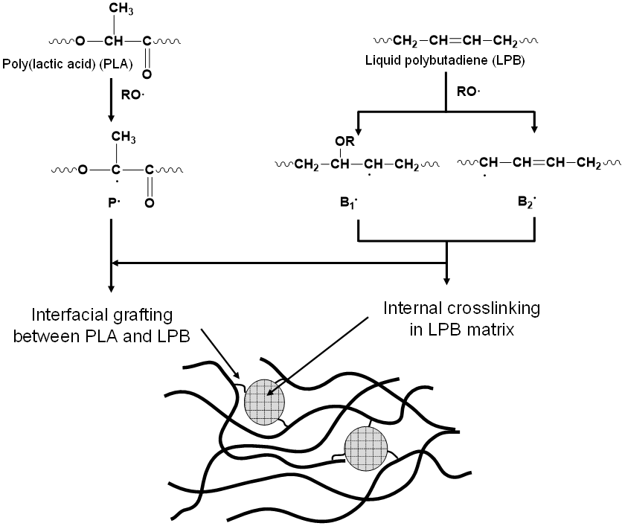

Scheme 1. Mechanism of the reactive blending of liquid polybutadiene (LPB) in poly(lactic acid) (PLA) matrix.

FT-IR spectroscopy was used to explain the chemical changes of the blends after the reactive blending as shown in Fig. 1. As for our previous work (Ha et al. 2016), PLA an LPB exhibited their characteristic absorption bands corresponding to their chemical groups such as the band absorption of C=O stretching by the ester groups at 1750 cm⁻¹ and the C-O stretching bands in -CH-O- and –O-C=O of PLA at 1181 cm⁻¹ and 1083 cm⁻¹ for LPB, as well as the intensive absorption bands of C-Н bond deformation oscillations in structures of trans-1,4-polybutadiene and 1,2-polybutadiene are observed at 965 cm⁻¹ and at 913 cm⁻¹, respectively, for LPB. As shown in the inset of Fig. 2, when the PLA and LPB was reactive-blended by addition of the DCP radical initiator, however, the absorption bands at 1658 and 1638 cm^{–1} were weakened and a broad peak at around 1650 cm⁻¹ newly appeared, suggesting the double bonds of LPB directly take part in the cross-linking or coupling reaction.

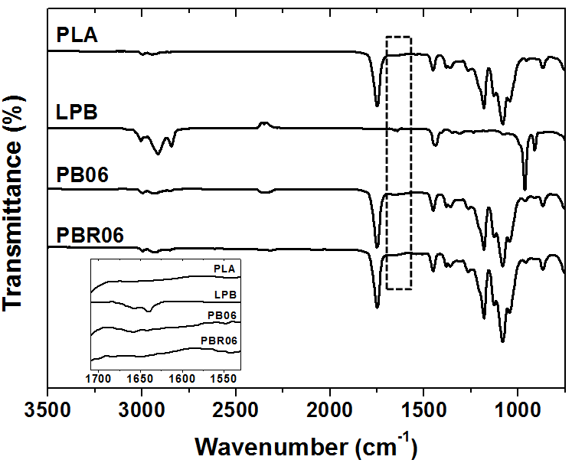

Fig. 1. FT-IR spectra of PLA, LPB, PB06, and PBR06. Inset is the enlarged view of the spectra between 1700 and 1550 cm⁻¹.

3.2. X-ray diffraction patterns

Fig. 2 describes the X-ray diffraction (XRD) patterns of the PLA and its blends that has been prepared with or without reactive blending, which were annealed at 110 ºC for 3 minutes. The neat PLA shows amorphous nature under the short annealing condition. For the PBs, a diffraction peak appears at around 16.9º. The peak intensity slightly increased with increasing the LPB content, which indicates that the added LPB plasticized PLA, though the effect is not so large. It implies that the LPB is not well-dispersed at a molecular level because it is not so compatible with PLA, when PLA is blended with LPB without reactive blending. On the contrary, PBRs which were prepared through reactive blending exhibit sharp and strong peaks and the peak intensity slightly increased with the increase of the LPB content. It suggests the crystallization rate is apparently enhanced after the reactive-blending.
When PLA and its blends were fully crystallized at 110 ºC for 20 minutes, diffraction peaks of the crystalline PLA appears at the 2θ values of 15.1°, 17.1°, 19.4°, and 22.7°, which are attributed to the (0 1 0), (1 1 0/2 0 0), (2 0 3), (0 1 5) reflection, respectively, as shown in Fig. 3 (Fu et al. 2012, Chen et al. 2012). The peaks at 2θ = 17.1°, 19.4°, and 22.7° are the characteristic peaks of α-form PLA, and those at 2θ = 15.1° and 19.4° are characteristic peaks of β-form crystal. The 2θ values of the (110/200) reflection for the PLA, PB06, and PBR06 appear at 16.93º, 16.79º, and 16.81º, respectively, which are slightly shifted lower angles for both of the blends, suggesting a certain conformational change of the PLA was occurred during blending.

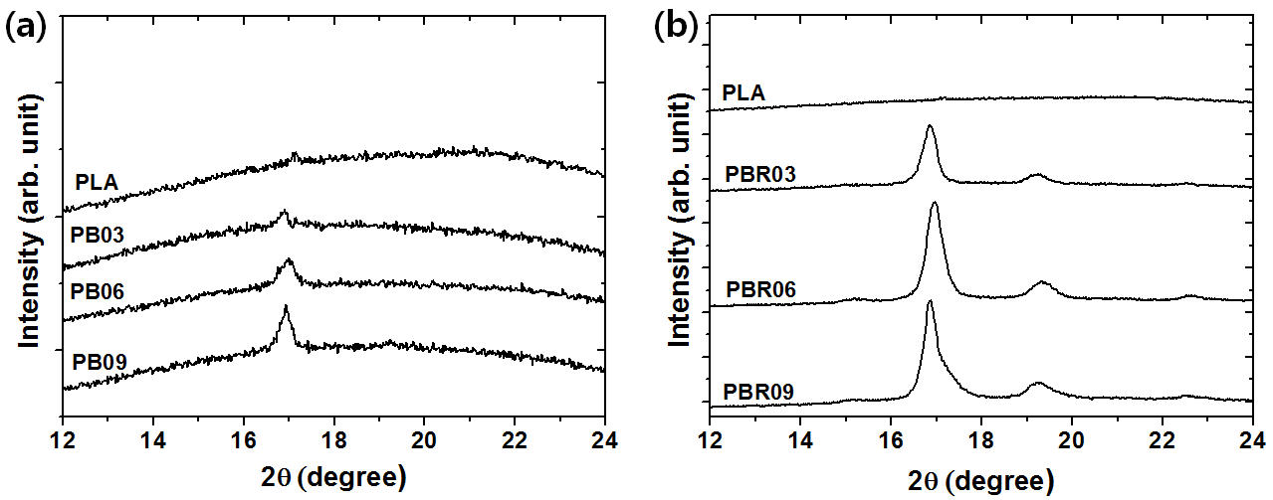

Fig. 2. WAXD patterns for neat PLA, PBs, and PBRs which were partially crystallized at 110 ºC for 3 min.

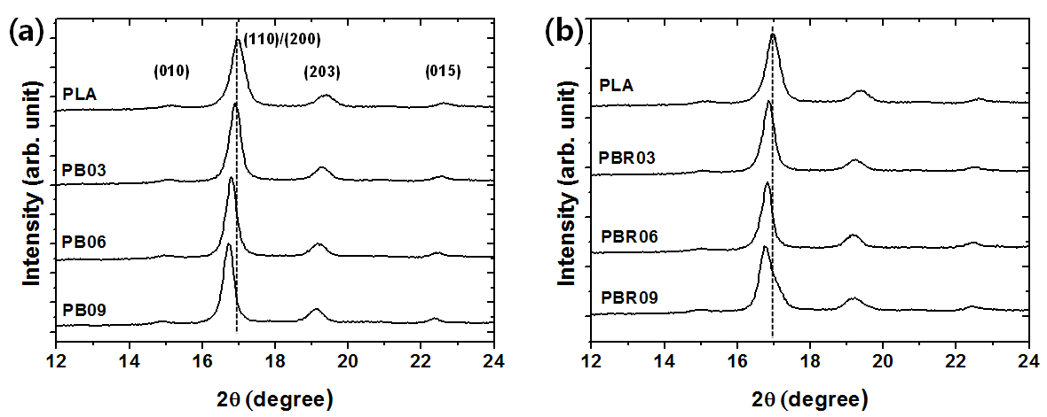

Fig. 3. WAXD patterns for neat PLA, PBs, and PBRs which were fully crystallized at 110 ºC for 20 min.

3.3. Thermal properties

Fig. 4 and Table 1 show thermal properties of the PLA/LPB blends such as glass transition temperature (Tg), cold crystallization temperature (Tc), and melting temperature (Tm) determined by DSC.

Table 1. Thermal properties of the pure PLA, PBs and PBRs with various LPB contents.
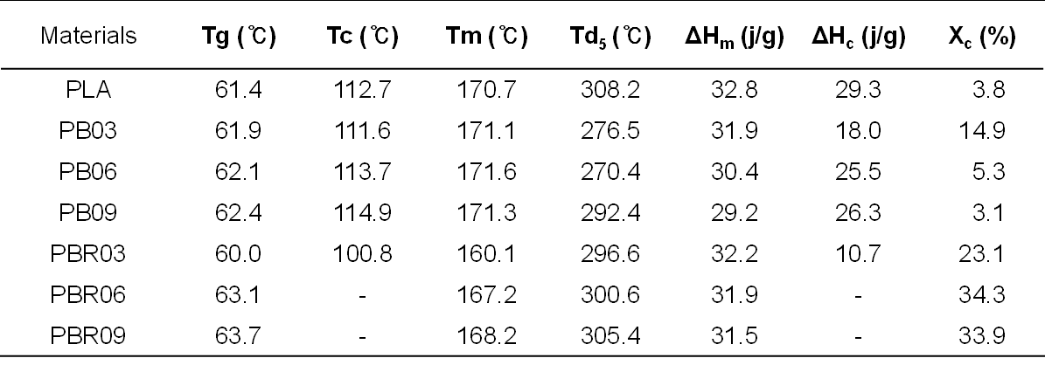

The enthalpy change in the cold crystallization is 29.3 J/g which is slightly smaller than that in the melting (32.8 J/g). It implies that most of PLA matrix keeps amorphous after cooling with the cooling rate of -10 ºC/ min. The Tgs of the PLA/LPB blends (without reactive blending; i.e. PB) are marginally shifted to higher temperature of 61.9, 62.1, and 62.4 ºC for the PB03, PB06, and PB09, respectively, while the Tg of PLA was 61.4 ºC. The Tcs and Tms for the PBs are similar to those of pure PLA (cold crystallization and melting temperatures at 112.7, and 170.7 ºC, respectively (Domb et al. 2008)) and even observed at a higher temperature than those of PLA. In general, plasticized PLA exhibits lower Tg, Tc, and Tm compared to pristine PLA (Zhang et al. 2011, Wesslén et al. 2005, McCarthy et al. 1997). These results imply that the intermolecular interaction between the polar PLA and non-polar LPB is quite poor and thus the plastic effect by the liquid LPB is not obvious. On the contrary, the Tgs of the PBRs (i.e reactive PLA/LPB blends) gradually increased with increasing LPB contents. Besides, the PBRs exhibit a single and broad melting peak and the Tms shoed decreasing trend to 170.1, 167.2 and 168.2 ºC for PBR03, PBR06, and PBR09, respectively. These explicitly indicates that the conformational structure of the PBRs are different from those of the PLA or PBs, which can be attributed to enhanced interaction between PLA and LPB by interfacial grafting. In addition, the cold crystallization which is apparently observed for the PLA and PBs disappeared for the PBR06 and PBR09. The disappearance of the cold crystalline peak indicates that the most of the amorphous phase in the PLA matrix were changed into crystalline phase during the cooling process. Namely, the crystallization rate was significantly enhanced by the reactive blending. The crosslinking or coupling sites formed by the macromolecular free radicals might act as nucleation cores, accelerating the crystallization of PLA (Ha et al. 2013, Ha et al. 2014).

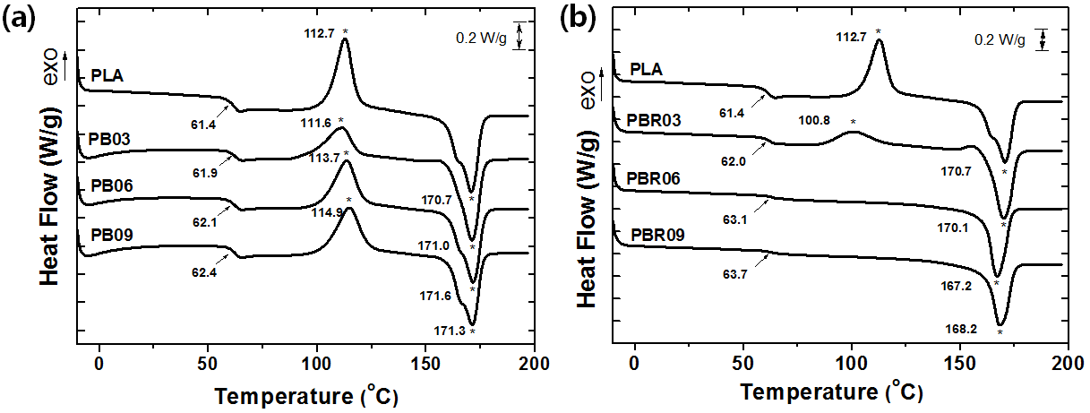

Fig. 4. DSC traces for pure PLA, PBs, and PBRs with various LPB contents.

The thermal degradation behaviors of the pure PLA and its blends were described in Fig. 5. The onset temperatures of the thermal degradation are 219, 223, and 262 ºC for PB03, PB06, and PB09, respectively. The thermal degradation temperature of PB series were apparently lowered from that of the PLA (288 ºC), but increased with the increase of the LPB content. The TGA curves of the PLA/LPB blends imply that the degradation first occurs at the ester linkage of the PLA and finished at the vinyl chains of the polybutadiene irrespective of the existence of the radical crosslinking by the DCP. It should be noted, however, that, as shown in the inset of Fig. 5b in terms of the onset of the weight loss temperature, the thermal stability of PBRs gradually increases with increasing the added LPB amount.

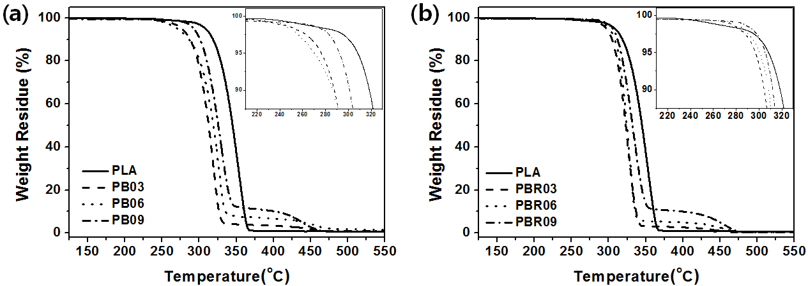

Fig. 5. TGA curves for pure PLA, PBs, and PBRs with various LPB contents.

3.4. Mechanical properties

Typical stress-strain curves of both PLA/LPB blends with or without reactive blending are displayed in Fig. 6. As known, PLA has rigid and brittle nature. It shows a high initial modulus of 3.9 GPa and then abruptly breaks at ultimate strain of 2.2%. On the contrary, the PBs and PBRs show an apparent plastic deformation between linear elastic deformation and rupture, indicating their fracture mode changed from brittle to ductile.

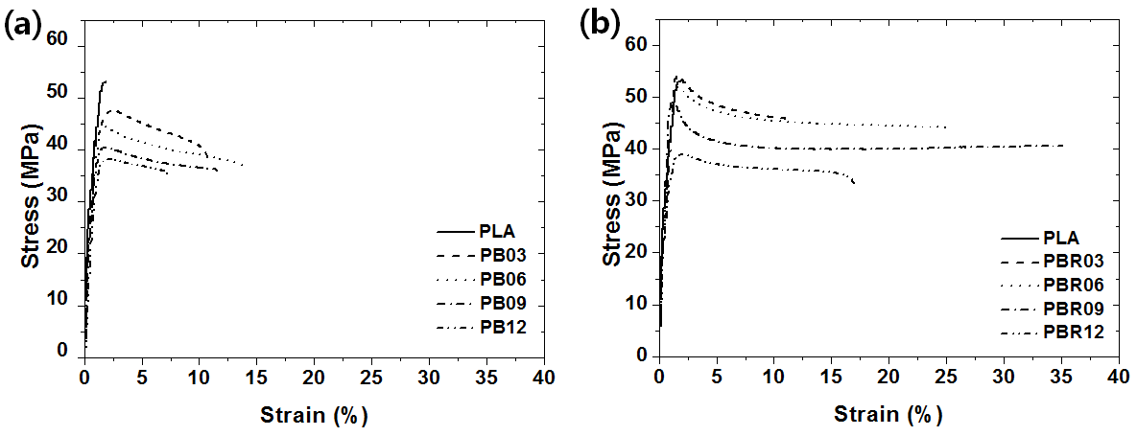

Fig. 6. Representative stress–strain curves of pure PLA, PBs, and PBRs with various LPB contents.

The tensile strengths of the PBs gradually decreased with increasing LPB content, while their elongations at break increased. For the PB06, it is 12.9 % which increased by ~ 6 times compared to pure PLA (Fig. 7a). However, it is not so high compared to some well-known plasticizers such as acetyl tributyl citrate (ATBC) which was reported to enhance the elongation of PLA by ~60 times (Zhang et al. 2011). Besides, the elongations decreased and the added LPB was leached out when the LPB contents are > 6 wt%. Compared to the optimal content (~25 wt%) for common polar liquid plasticizers, it is quite small for the LPB, a non-polar plasticizer. Interestingly, PBRs exhibits excellent toughness. The elongation was enhanced by more than > 16 times compared to the pure PLA. Of particular note, it is considerably improved even compared to the PBs. The tensile strengths of the PBR03, PBR06, and PBR09 are 54.3, 51.9, and 49.4 MPa, respectively (Fig. 7b). They slightly reduced and even marginally increased for the PBR03 compared to 53.2 MPa for pure PLA. It suggests that the elastomeric rubber greatly affects to the tensile properties even though the added amount is small and the crosslinking behavior by the added liquid rubber can be important factor to control the elastic properties. As a result, it was confirmed again that the liquid polybutadiene (LPB) is an excellent agent for toughening PLA with the help of radical-induced reactive blending, which can improve miscibility and entanglement of the rubber particles in the PLA matrix, as was preliminarily for our previous work (Ha et al. 2016).

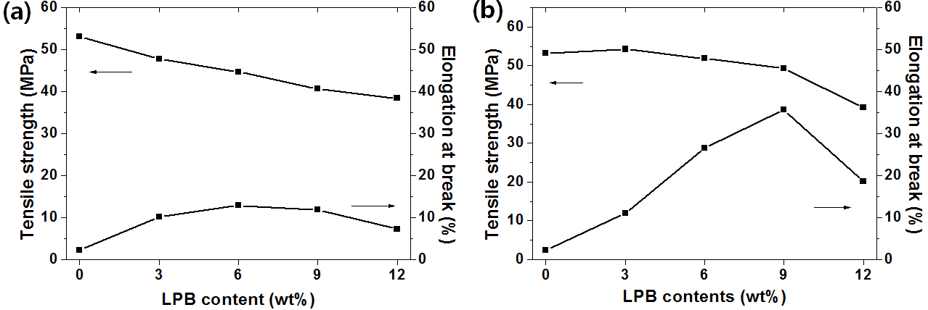

Fig. 7. Changes in tensile strength and elongation at break of pure PLA, PBs, and PBRs against the added LPB contents in PLA.

3.5. Morphology

The morphology analysis of the fractured surface of the blends was conducted to study dispersibility of the LPB in PLA matrix. The fractured surface of the pure PLA illuminates its brittle nature without any evidence of heterogeneities (Fig. 8). However, the fractured surfaces of the PBs and PBRs are obviously rough, showing particle-like fragments covering on the surfaces. The PBs which is prepared by melting blends without the radical initiator has a quite heterogeneous morphology. The LPB domain sizes increased when the LPB content increased while the size and shapes are quite various even in the same materials. It might be due to the poor interfacial adhesion between the LPB and PLA, Note that polybutadiene is nonpolar and thus it is immiscible with the relatively polar PLA.

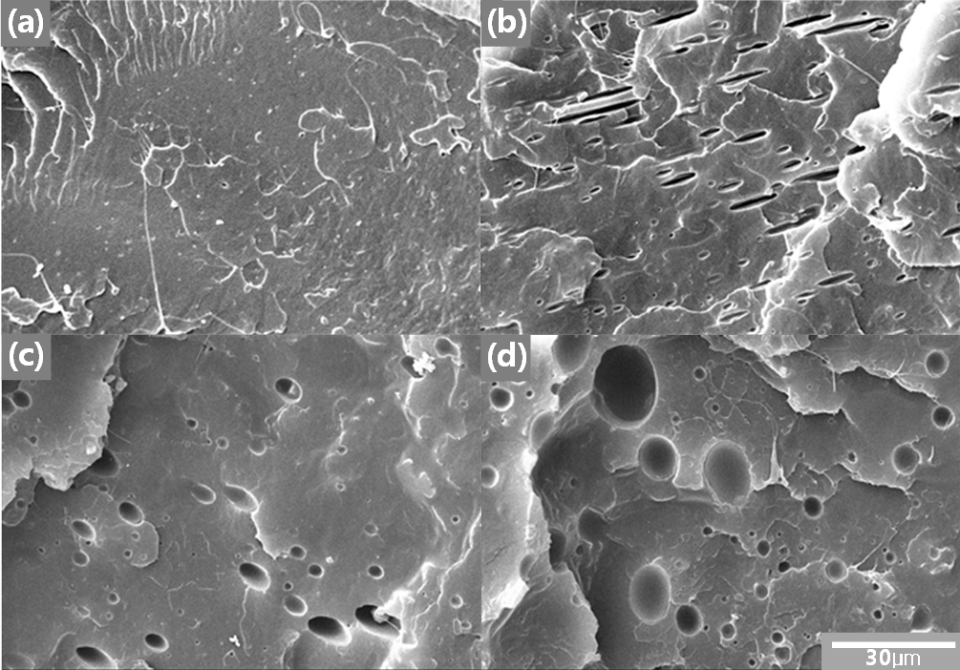

Fig. 8. SEM images of pure PLA and PBs with various LPB contents; (a)PLA, (b)PB03, (c) PB06, and (d) PB09.

On the contrary, PBRs prepared by adding the radical initiator into PLA/LPB blends display significantly reduced domain size in the PLA matrix (Fig. 9), when comparing them with Fig. 8 for PB without reactive blending. The partial grafting between PLA and LPB might enhance the compatibility between two phases, reducing the rubber particles size in PLA matrix. It is well-known that the size and substructure of the dispersed rubber modifier play a crucial role in determining the ultimate toughening effect and the deformation mechanism (Zhang et al. 2011).

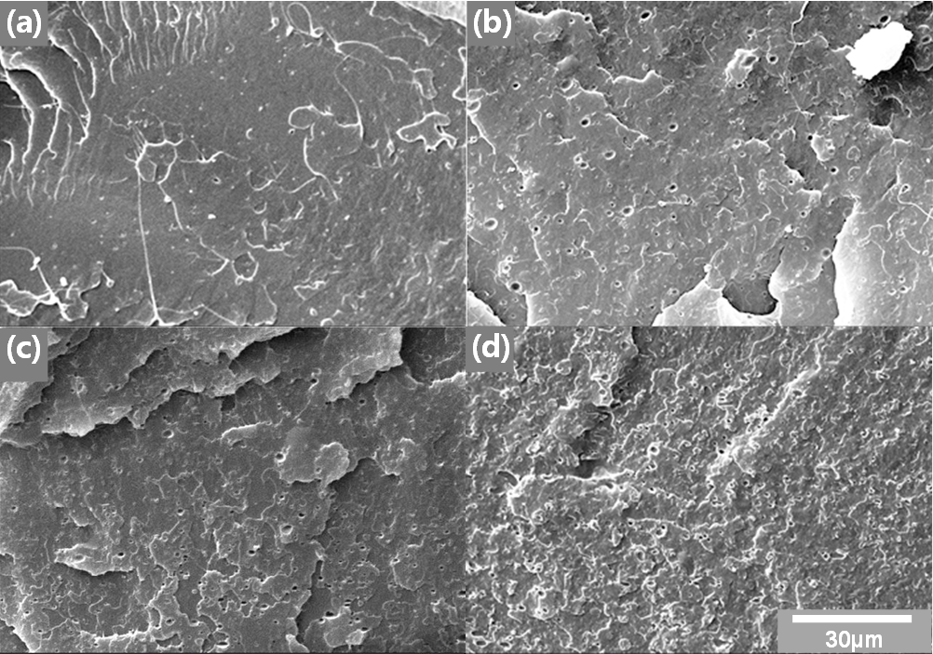

Fig. 9. SEM images of pure PLA and PBRs with various LPB contents; (a)PLA, (b)PBR03, (c) PBR06, and (d) PBR09.

3.6. Hydrolytic degradation properties

PLA has been under investigation for biomedical and pharmaceutical applications such as orthopedic fixture materials, degradable sutures, absorbable fibers, and controlled-release devices, etc. Biodegradable polyesters are known to be degraded by the uptake of water followed by the hydrolysis of ester bonds. The pH is an important factor in the hydrolysis of these polymers, because hydrolysis is catalyzed by both acid and base. Degradation study was carried out in water at a pH of 10.5 and 60 °C. Fig. 10 describes the weight loss of PLA and the blends as a function of time. The pure PLA was hydrolytically degraded by 48.8 wt% after 30 days in the buffer solution. The weight loss by the hydrolytic degradation of the PB03, PB06, and PB09 are 42.4, 39.3, and 37.9 wt%, which are gradually delayed when the LPB contents increased. Besides, the degradation rate was getting slower after the reactive blending. It is reduced by 25% for the PBR09 compared to that of the PB09. In general, various factors such as the presence of a crystalline phase, the glass transition temperature of the amorphous phase, and the hydrophilicity can influence the degradation rate of the PLA (Ha et al. 2013, Ha et al. 2014). It suggests that the hydrophobic nature of the LPB might impede polar water molecules to approach to PLA chains. In addition, the homogeneously dispersed LPB domains might delay water penetration into the PLA matrix to reduce the hydrolytic degradation as well as thermal degradation of the ester groups in the PLA chains.

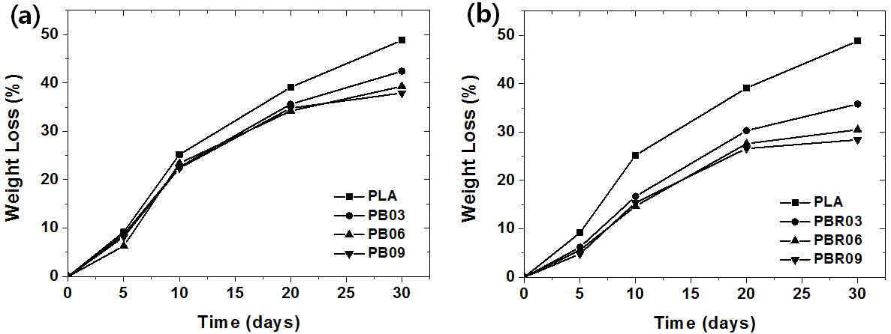

Fig. 10. Weight loss for neat PLA, PBs, and PBRs with various LPB contents in NaHNO₃/NaOH buffer solution (pH 10.5, 60ºC) plotted against time during hydrolytic degradation.

4. Conclusions

Poly(lactic acid) (PLA) was toughened by a liquid rubber, polybutadiene (LPB). The toughened PLAs were prepared by melt-blending the PLA with various contents(0, 3, 6, and 9 wt.%) of the LPB and following reactive-blending in the presence of dicumyl peroxide (DCP), a radical initiator. The WAXD patterns and DSC thermograms for the PBRs revealed that the radical induced reactive-blending apparently increased crystallization rate without any remarkable changes in crystallinity. The morphology of the rubber phases was significantly changed through the reactive-blending, illustrating that the compatibility between PLA and LPB was apparently enhanced and the rubber particles were homogeneously dispersed at the nanoscale in the PLA matrix. The changes in the conformational structure enhanced the toughness of the rigid PLA. The tensile strength of the PBRs was slightly reduced but even marginally increased for the PBR03 and the elongations, in particular, are remarkably improved by more than 1,600% compared to the pure PLA. It suggests that the elastomeric rubber greatly affects to the toughness as like the rubber-modified high impact polystyrene despite its small content in PLA matrix, and the crosslink or vulcanization of the added rubber might be important factor to control the elastic properties. Following our preliminary work that dealt with PLA/LPB blend of only 10 wt. % of LPB composition (Ha et al. 2016), it was confirmed again that the radical initiator enhanced dispersibility of the rubber phases in the PLA matrix and solidified the liquid rubber through crosslinking to improve the toughness of the PLA, which significantly affected physico-chemical properties of PLA, even under various LPB compositions up to 9 wt. % of LPB. In conclusion, the toughness of the rubber-modified PLA was significantly enhanced through the reactive blending, which is promising for the practical application of the toughened PLA in the area of packaging.

Acknowledgements

The work was financially supported by the National Research Foundation of Korea (NRF) Grant funded by the Ministry of Science and ICT, Korea (NRF–2017R1A2B3012961; Brain Korea 21 Plus Program (21A2013800002)).

References
Auras, R., Harte, B., and Selke, S. (2003), “Mechanical, physical, and barrier properties of poly(lactide) films”, J. Plastic Film Sheeting, 19(2), 123-135.
Chen, B.-K., Shih, C.-C., and Chen, A. F. (2012) “Dutile PLA nanocomposites with improved thermal stability”, Composites Part A: Appl. Sci. Manuf. , 43(12), 2289-2295.
Zhang, J., Tashiro, K., Tsuji, H., and Domb, A. J. (2008), “Disorder-to-Order Phase Transition and Multiple Melting Behavior of Poly(L-lactide) Investigated by Simultaneous Measurements of WAXD and DSC”, Macromolecules, 41(4), 1352-1357.
Choi, K.-M., Choi, M.-C., Han, D.-H., Park, T.-S., and Ha C.-S. (2013), “Plasticization of poly(lactic acid) (PLA) through chemical grafting of poly(ethylene glycol) (PEG) via in situ reactive blending”, Eur. Polym. J., 49(8), 2356-2364.
Choi, K.-M., Choi, M.-C., Han, D.-H., Kim, Y.-M., Lim, S.-W., and Ha C.-S. (2014), “Thermal and mechanical properties of poly(lactic acid) modified by poly(ethylene glycol) acrylate through reactive blending”, Polym. Bull., 71(12), 3305-3321.
Choi, K.-M., Choi, M.-C., Han, D.-H., Lim, S.-W., and Ha C.-S. (2014), “Properties of poly(ethylene glycol)-grafted poly(lactic acid) plasticized with poly(ethylene glycol)”, Macromol. Res., 22(12), 1312-1319.
Gao, J., Duan, L., Yang, G., Yang, M., Zhang, Q., and Fu, Q. (2012), “Manipulating poly(lactic acid) surface morphology by solvent-induced crystallization”, Appl. Surf. Sci., 261(15), 528-535.
Garlotta, D. (2001), “A Literature Review of Poly(Lactic Acid)”, J. Polym. Environ., 9(2), 63-84.
Hassouna, F., Addiego, F., Dubois, P., Raquez, J.-M., Toniazzo, V., and Ruch, D. (2011), “New approach on the development of plasticized polylactide (PLA): Grafting of poly(ethylene glycol) (PEG) via reactive extrusion”, Eur. Polym. J., 47(11), 2134-2144.
Hassouna, F., Addiego, F., Dubois, P., Raquez, J.-M., Toniazzo, V., and Ruch, D. (2012), “New development on plasticized poly(lactide):Chemical grafting of citrate on PLA by reactive extrusion”, Eur. Polym. J., 48(2), 404-415.
Ho, C.-H., Lin, C.-I., Wang, C.-H., and Lee, Y.-D. (2008), “Synthesis and characterization of TPO-PLA copolymer and its behavior as compatibilizer for PLA/TPO blends”, Polymer, 49(18), 3902-3910.
Hu, Y., Hiltner, A., Hu, Y. S., Topolkaraev, V., and Baer, E. (2003), “Crystallization and phase separation in blends of high stereoregular poly(lactide) with poly(ethylene glycol)”, Polymer, 44(19), 5681-5689.
Hu, Y., Hiltner, A., Topolkaraev, V., and Baer, E. (2003), “Aging of poly(lactide)/poly(ethylene glycol) blends. Part 1. Poly(lactide) with low stereoregularity”, Polymer, 44(19), 5701-5710.
Jacobsen, S., and Fritz, H. G. (1999), “Plasticizing polylactide—the effect of different plasticizers on the mechanical properties”, Polym. Eng. Sci., 39(7), 1303-1310.
Jamshidi, K., Hyon, S.-H., and Ikada, Y. (1988), “Thermal characterization of polylactides”, Polymer, 29(12), 2229-2234.
Labrecque, L. V., Davé, V., Gross, R. A., Kumar, R. A., and McCarthy, S. P. (1997), J. Appl. Polym. Sci., 66(8), 1507-1513.
Li, Y., and Shimizu, H. (2009), “Improvement in toughness of poly(l-lactide) (PLLA) through reactive blending with acrylonitrile–butadiene–styrene copolymer (ABS): Morphology and properties”, Eur. Polym. J., 45(3), 738-746.
Lim, L.-T., Auras, R., and Rubino, M. (2008), “Processing technologies for poly(lactic acid)”, Prog. Polym. Sci., 33(8), 820-852.
Lim, S.-W., Choi, M.-C., Jeong, J.-H., Park, E.-Y., and Ha, C.-S. (2016), “Toughening poly(lactic acid) (PLA) through in situ reactive blending with liquid polybutadiene rubber (LPB)”, Compos. Interf., 23(8), 807-818.
Liu, H., Chen, F., Guo, L., Song, W., and Zhang, J. (2011), “Interaction of Microstructure and Interfacial Adhesion on Impact Performance of Polylactide (PLA) Ternary Blends”, Macromolecules, 44(6), 1513-1522.
Ljungberg, N., Andersson, T., and Wesslén, B. (2003), “Film extrusion and film weldability of poly(lactic acid) plasticized with triacetine and tributyl citrate”, J. Appl. Polym. Sci., 88(14), 3239-3247.
Ljungberg, N., and Wesslén, B. (2002), “The effects of plasticizers on the dynamic mechanical and thermal properties of poly(lactic acid)”, J. Polym. Sci. Polym. Phys., 86(5), 1227-1234.
Ljungberg, N., and Wesslén, B. (2005), “Preparation and properties of plasticized poly(lactic acid) films”, Biomacromolecules, 6(3), 1789-1796.
Ljungberg, N., and Wesslén, B. (2003), “Tributyl citrate oligomers as plasticizers for poly (lactic acid): thermo-mechanical film properties and aging”, Polymer, 44(25), 7679-7688.
Luckachan, G. E., and Pillai, C. K. S. (2011), “Biodegradable polymers - a review on recent trends and emerging perspectives”, J. Polym. Environ., 19(3), 637-676.
Lui, H., and Zhang, J. (2011), “Research Progress in Toughening Modification of Poly(lactic acid)”, 49(15), 1051-1083.
Liu, X., Liu, Y., Yuanb, C., Zhang, A., Zhou, T., and Zhang, W. (2015), “Cross-linking process of cis-polybutadiene rubber with peroxides studied by two-dimensional infrared correlation spectroscopy: a detailed tracking”, RSC Adv., 5(14), 10231-10242.
Lunt, J. (1998), “Large-scale production, properties and commercial applications of polylactic acid polymers”, Polym. Deg. Stab., 59(1-3), 145-152.
Martin, O., and Averous, L. (2001), “Poly(lactic acid): plasticization and properties of biodegradable multiphase systems”, Polymer, 42(14), 6209-6219.
Mehta, R., Bhunia, H., Kumar, V., and Upadhyay, S. N. (2005), “Synthesis of poly(lactic acid): A review”, J. Macromol. Sci. Part C, 45(4), 325-349.
Migliaresi, C., Cohn, D., De Lollis, A., and Fambri, L. (1991), “Dynamic mechanical and calorimetric analysis of compression-molded PLLA of different molecular weights: Effect of thermal treatments”, J. Appl. Polym. Sci., 43(1), 83-95.
Kulinski, Z., Gadzinowska, K., Piorkowska, E., and Stasiak, M. (2006), “Plasticization of poly(L-lactide) with poly(propylene glycol)”, Biomacromolecules, 7(7), 2128-2135.
Okamoto, K., Ichikawa, T., Yokohara, T., and Yamaguchi, M. (2009), “Miscibility, mechanical and thermal properties of poly(lactic acid)/polyester-diol blends”, Eur. Polym. J., 45(8), 2304-2312.
Oyama, H. (2009), “Super-tough poly(lactic acid) materials: Reactive blending with ethylene copolymer’, Polymer, 50(3), 747-751.
Vroman, I., and Tighzert, L. (2009), “Biodegradable Polymers”, Materials, 2(2), 307-344.
Siracusa, V., Rocculi, P., Romani, S., and Rosa, M.D. (2008) “Biodegradable Polymers for Food Packaging: A Review”, Trends Food Sci. Tech. 19(12), 634-643..
Zhang, W., Chen, L., and Zhang, Y. (2009), “Surprising shape-memory effect of polylactide resulted from toughening by polyamide elastomer’, Polymer, 50(5), 1311-1315.

