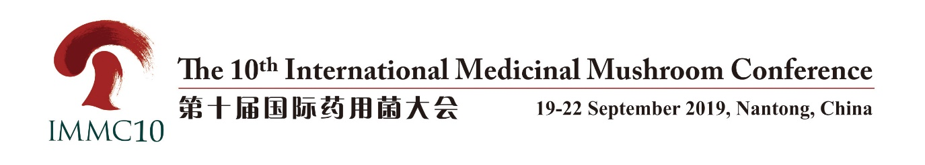
Call for papers
Abstract
We would be pleased to receive abstracts from interested authors that follow the symposia themes. Abstracts should focus on current issues relevant ongoing research and/or progress made in culinary-medicinal mushroom industry and should be scientific and/or of technical content.
Your abstracts should clearly define the objectives of the presentation or the topics covered, key conclusions reached, and potential benefits for scientific development and progress made in the industry. Abstracts should not be more than 500 words but not less than 300.
The abstracts will be published in a book of abstracts, which will be printed and distributed to the participants at the conference.
The electronic version must be prepared in Microsoft Word format and in the required abstract form (download from www.immc10.com). It should be submitted online (www.immc10.com) before June 5, 2019.

Different symposia dedicated to:
- Biodiversity and Ethnomycology of Medicinal Mushrooms (Conservation, Taxonomy Ecological Distribution, Historical and Sociological Impact);
- Genetics and Breeding of Medicinal Mushrooms (including Molecular Biology);
- Cultivation and Fermentation of Medicinal Mushrooms;
- Biochemistry and Pharmacology of Medicinal Mushrooms’ Active Compounds;
- Medicinal Mushrooms in Veterinary and Agriculture;
- Medicinal Mushrooms in Clinical Practice;
- Nutritional and Medicinal Values of Mushroom Products;
- Industrialization of Medicinal Mushrooms Products (including Management, Marketing, Laws and Regulations, Standardization).

Sample of abstract

The Role of Culinary-Medicinal Mushrooms on Human Welfare with a Pyramid Model for Human Health

Shu Ting Chang¹, Solomon P. Wasser²
¹Centre for International Services to Mushroom Biotechnology, Department of Biology, The Chinese University of Hong Kong, Hong Kong, SAR, China; ²International Center for Biotechnology and Biodiversity of Fungi, Institute of Evolution, and Department of Evolutionary and Environmental Biology, Faculty of Natural Sciences, University of Haifa, Haifa, Israel; N.G. Kholodny Institute of Botany, National Academy of Sciences of Ukraine, Kiev, Ukraine
E-mail: scha6507@bigpond.net.au.

Abstract: Mushrooms are part of fungal biota characterized by wonder. They rise up from lignocellulosic wastes: yet they become so bountiful and nourishing. Mushrooms are environmentally friendly. They biosynthesize their own food from agricultural crop residues, which would otherwise cause health hazards. The extant records show the continued use of some mushrooms, e.g., Lentinus edodes, Ganoderma lucidum, and Cordyceps sinensis are now centuries old. This review presents a pyramid model for mushroom uses (industries), as food, dietary supplements (tonic), and medicine. A regular intake of mushrooms can make us healthier, fitter, and happier, and help us live longer. The sense of purpose and vision for the mushroom industries is also briefly discussed. A variety of mushrooms have been used traditionally in many different cultures for the maintenance of health and in the prevention and treatment of various diseases. A total of 126 medicinal functions are thought to be produced by medicinal mushrooms (MM) and fungi, including antitumor, immunomodulating, antioxidant, radical scavenging, cardiovascular, anti-hypercholesterolemia, antiviral, antibacterial, anti-parasitic, antifungal, detoxification, hepatoprotective, and anti-diabetic effects. Special attention is paid to mushroom polysaccharides. Many, if not all, higher Basidiomycetes mushrooms contain biologically active polysaccharides in fruit bodies, cultured mycelium, and cultured broth. The data on mushroom polysaccharides are summarized for approximately 700 species of higher Hetero- and Homobasidiomycetes. In particular, the most important for modern medicine are polysaccharides with antitumor and immunostimulating properties. Several of the mushroom polysaccharide compounds have proceeded through phase I, II, and III clinical trials and are used extensively and successfully as drugs in Asia to treat various cancers and other diseases. Mushrooms are superior sources of different types of dietary supplements (DSs) (tonics). The advantages of using mushroom-based DSs as a matter of safety (as opposed to herbal preparations) are: (1) The overwhelming majority of mushrooms used for production of DSs are cultivated commercially (and not gathered in the wild). (2) Mushrooms are easily propagated vegetatively and thus keep to one clone. The mycelium can be stored for a long time, and the genetic and biochemical consistency can be checked after a considerable time. (3) The main advantage, in our opinion, is that many mushrooms are capable of growing in the form of mycelial biomass in submerged cultures. In this review, we discuss legal and regulatory issues introducing and controlling DSs from MMs in different countries, including the United States, the European Community, Australia, New Zealand, Japan, and P.R. China, and guidelines of the World Health Organization. One of the targets of the present review is also to draw attention to many critically important unsolved problems in the future development of medicinal mushroom science in the 21st century.
Key words: antibacterial properties, antifungal properties, antineoplastic properties, antioxidants

