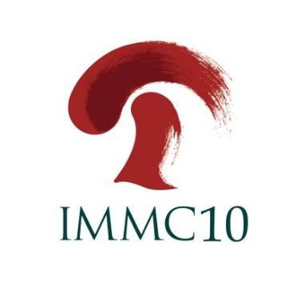

SPONSORSHIP APPLICATION FORM

Please complete and return this form to IMMC10 organizers: expo@immc10.com
T:+86-10-87109860; F:+86-10-87109861
Company Name
Contact person |  | Title
Address
City/State/Province
Country |  | Zip/Postal Code
Phone |  | Fax
Email

We would like to sponsor the following items:
ITEMIZED SPONSORSHIP OPPORTUNITIES | Cost ($US) | √
Diamond Sponsor | 30,000
Gold Sponsor | 15,000
Silver Sponsor | 8,000
Bronze Sponsor | 5,000
Friend Sponsor | 1,500

Authorized Signature: _________________________ Date:____________________

